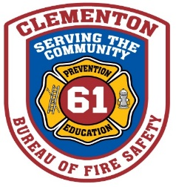
CLEMENTON FIRE MARSHAL’S OFFICE

ANNUAL PRIVATE FIRE HYDRANT INSPECTION FORM
(Please complete one form per hydrant)

NOTE: USE THE TAB BUTTON TO MOVE CURSOR

Property Name or Address:
Testing Agency Name:
Inspector:
Hydrant Location:
Date: / /20

Hydrants accessible Yes No
No obvious leaks Yes No
No obvious damage Yes No
Adequate vehicle protection (parking areas) Yes No
Caps are easy to remove Yes No
Threads on outlets free of damage and lubricated during inspection Yes No
Stem operates smoothly Yes No
Hydrant fully opened during inspection Yes No
Adequate Flow (visual inspection) Yes No
Hydrant adequately drains after closing Yes No
Please explain deficiencies:

Borough of Clementon
Bureau of Fire Safety
101 Gibbsboro Road
Clementon, NJ 08021
P: 856-783-0284, Ext. 123
F: 856-783-3419

